Ridgeway R-V School

Preschool Student Handbook

2024-2025



MISSION STATEMENT

The Ridgeway R-V School District consistently strives for academic achievement by promoting a positive learning environment. We promote citizenship, communicate high expectations, and recognize success.

Ridgeway R-V

2024-2025 FACULTY/STAFF

**Board of Education**

Scott Billups………..President Miles McGovney……….. Member

Sydney Craig……….Vice President Sarah Linthacum………... Member  
Austin Booth………..Secretary / Treasurer Brett Kilton ……….......... Member

John Meek………………. Member

**Administration:**

Jonnie Beavers, Superintendent

Daniel Brooks, Principal & AD

**Office:**

April Holcomb, Board Secretary and District Bookkeeper

Chrissy Wiig, District Secretary

Valerie Wink, District Counselor

Kindergarten Kadie Wagner K-12 Music/Art Brandi Cook

1st Grade Lauren Kriewitz PE/Health Patrick Friga

2nd/3rd Grades Hope Ellsworth Business Betsy Friesz  
4th/5th Grades Adrie DeVries SPED Coord./FACS Jamie Israel

Title I Reading/Math Jandy Whitaker 6-12 English Penelope Wallace  
Library/PAT Shelley Lovitt 6-12 Science Esabel Holt

Preschool/Library Brandy Cook 6-12 Social Studies Karl (KJ) Dailey

Special Education Bryndee Ray 6-12 Mathematics Brooke Hecker

Maintenance/Custodian Scott Boswell  
Custodian Betty Seymour

Tammy Bennett PK Paraprofessional  
Stephanie Thurston Paraprofessional

Food Service Director Jolene Giles

Cook Molly Parkhurst

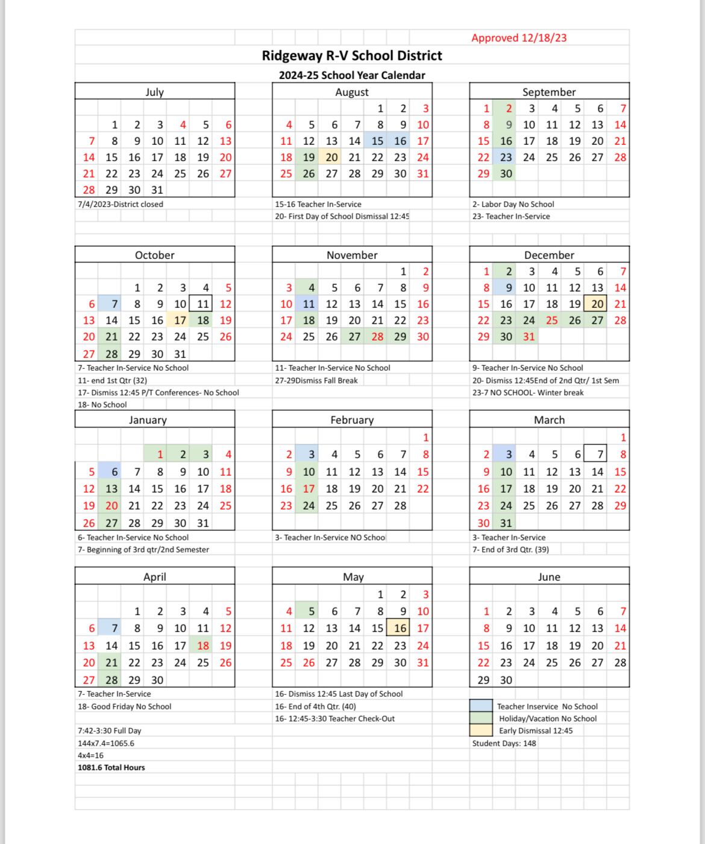

FOREWORD

The procedures and guidelines outlined in this handbook have been formulated to provide information to the students and parents of Ridgeway R-V School. These rules are necessary for the effective day-to-day operation of our school and shall be applied in a firm, fair and consistent manner.

**We know that everyone associated with Ridgeway R-V School District wants the best education experience for all of our students. Please read this handbook carefully, then sign and** return the attached Handbook Consent Form before the end of the first full week of school.

**Program Philosophy and Goals:**

Ridgeway R-V Preschool is a locally funded preschool designed to meet the developmental needs of three and four-year olds in the Ridgeway school district and surrounding area. Enrollment priority is given to those children living in the Ridgeway school district and those entering Kindergarten the following year, with remaining vacancies available to children living in the surrounding areas.

The mission of the Ridgeway School District is to provide a challenging curriculum in a positive learning environment that supports individual and community needs while promoting lifelong learning. We strive to create an environment that is developmentally appropriate for all children.

Our focus is to encourage:

* intellectual growth * a sense of belonging * discovery

* physical growth * involvement * happiness

* self-expression * creativity * cooperation

* problem solving * curiosity * independence

* imagination * sensitivity

Our responsibility is to ensure that children are:

* safe * respected * appreciated * challenged

Our learning experiences and center play focuses on themes that are created to meet your child’s interests. Our preschool provides many hands-on and developmentally appropriate experiences such as:

* Circle times with calendar, sharing, singing, and stories
* Sensory play such as sand and water play that provides opportunities for children to think, reason, question, and experiment.
* Art projects that focus on the process rather than the end result
* Dramatic play and creative movement
* A hands-on approach to basic math concepts
* Language Arts activities that help them develop listening skills, reading readiness skills, and increase vocabulary growth.

It is our goal at Ridgeway Preschool to create open lines of communication. Your involvement and interest will enhance your child’s development. After all, who knows your child better than you do? We encourage all parents to get involved and participate in any way you can.

**How Parents Can Help:**

* Make sure your child gets plenty of sleep.
* Encourage a good, healthy diet, including breakfast.
* Dress your child in comfortable clothing.
* Read to your child daily.
* Encourage your child to tell you about his/her day.
* Be generous with your praise and encouragement.
* Encourage your child to be proud of his/her accomplishments.

**Behavior Management:**

One of the most important goals of preschool is social growth. We feel discipline and learning to react to difficult situations is important. The preschool staff uses a discipline and behavior plan called Conscious Discipline developed by Dr. Becky Bailey. In this plan, each individual behavior is an opportunity to learn to make better choices. When a discipline issue arises, it is treated as an opportunity to teach the children a better way to deal with his/her frustration. Rules or classroom ideas are created on an as needed basis and are discussed and written as a school family. When a rule or idea is broken we deal individually with each situation to create a consequence that will fit the problem and ultimately teach a lesson on choosing better behavior. Typical guidance you will see in our classroom include:

1. Discussion ahead of time about what is safe and what is expected.
2. Discussion about what children think should happen if an inappropriate decision is made.
3. When an inappropriate action occurs, a discussion about how the situation should look.
4. Follow through on a consequence that will teach a lesson about the behavior (ex. Cleaning the marker off the table, helping a friend rebuild their tower, apologizing for hitting and them leaving the activity)

**Program Design & Operations:**

The preschool instruction time for children age 3 will be from 7:45-11:16 am Tuesday through Friday. If your child will be eating school breakfast, he/she will need to be at school by 7:25 am. If your preschool child will eat school lunch, they will need to be picked up no later than 11:16 am. For those students who are not eating school lunch, dismissal time is 10:50 am. The preschool instruction time for children ages 4 & 5 will be from 7:45 am-3:30 pm Tuesday through Friday. If your child will be eating school breakfast, he/she will need to be at school by 7:25 am, and dismissal time is 3:30 pm. NO SCHOOL ON MONDAY.

* Our program is designed to serve as a four day per week, half-day preschool for children age 3 and full-day preschool for children ages 4 & 5 as of August 1 of the current school year.
* Ridgeway R-V Preschool is a 9-month program, which will follow the district calendar.
* Children must be potty trained and be able to use the restroom with no assistance.
* If our program reaches a maximum of 12 students enrolled, only Ridgeway residents who are eligible for kindergarten the following year will be considered for enrollment.
* Anyone living in the surrounding area may request enrollment at Ridgeway Preschool for their three or four-year old but Ridgeway residents and those entering Kindergarten the following year will have priority admission.
* We must have a copy of up-to-date immunizations on file for each student.
* Parent questionnaires are given upon completion of the program in order to assess strengths and concerns of the program.
* Developmental screenings are used to evaluate the amount of growth of the children enrolled in the program; the children will be evaluated upon entering and exiting the program.
* Monthly newsletters and calendars are sent home informing parents of preschool activities.

**Absences:**

Daily attendance is very important in order for your child to receive the maximum benefits of the preschool program. Of course, we expect preschoolers to experience all the “kid illnesses” and want them to stay home if they are ill. If your child is absent for any reason (including illness and vacation), it is important that we are notified as soon as possible. Please call the school at 872.6813 before 9:00 am that morning. We ask for your cooperation in scheduling doctor/hair appointments, etc. outside the normal school hours.

**Accidents at School/Emergency Procedures:**

Parents will be notified by phone or in writing in case of an accident or illness to their child. If you cannot be reached to make necessary arrangements, or in a critical emergency requiring medical care, the school will phone the person/persons you listed on your child’s enrollment form to authorize treatment.

All major and minor injuries will be documented and an accident report will be filled out and sent home with the child explaining the injury. A copy of the accident report will also be given to the principal.

Parents of all enrolled children are required to submit a medical release form giving the preschool permission to seek medical attention for the child in case of a medical or dental emergency. The parents must update the preschool on any changes in home, work, and medical phone numbers.

In the case of an accident, the following emergency procedures will be used:

1. A staff member will carry out immediate first aid.
2. A staff member will contact the parent to come and take the child to the doctor or dentist if medical care is necessary.
3. In case the parents or emergency contact person cannot be reached, the teacher will have the authority to call the designated physician or dentist, or local emergency unit for treatment and/or transportation to a hospital. A staff member will accompany the child to the hospital and stay until the parent arrives.

All injuries and accidents will be recorded on an accident report and given to parents.

**Authorized Pick-Up:**

For safety purposes, your child will not be allowed to leave with someone who is not listed on the Child Enrollment form. If you need someone to pick up your child that is not on the list, you must call the principal’s office or contact the preschool teacher.

**Clothing:**

Children should dress comfortably, simply, and suitably for the weather. We will engage in a number of messy activities that can get children dirty. An extra set of clothes (well labeled) should be left at the preschool permanently in case of accidents.

**Early Dismissal/Closing:**

In the event that school is dismissed early, a parent or specified responsible adult will need to pick up your child. Dismissal for inclement weather or school closing will be announced through text alert (free sign up at www.onlinefarmersbank.com) and KAAN radio station.

**Health Screenings:**

Hearing and vision screenings will be done annually at no cost to parents.

**Illness:**

When a child exhibits one or more of the behaviors 1-4, he/she CANNOT remain at the preschool. When a child exhibits one or more of the behaviors 5-12, a decision will be made by the teacher regarding the dismissal of the child. If the child is to be dismissed, the parent will be notified and the child must be picked up.

In cases in which the parent cannot be reached, the emergency number listed by the parent will be called. The child will be released to that person.

Signs of illness include the following:

1. Temperature of 100 degrees or more
2. Diarrhea and/or vomiting two times or more in a 24 hour period
3. Pink eye
4. Evidence of lice infestation, scabies, or other parasitic infestation
5. Severe coughing
6. Skin rash
7. Sore throat or difficulty in swallowing
8. Difficult or rapid breathing
9. Complaints by child or fussiness
10. “Listless” behavior
11. Symptoms of a cold
12. Decreased appetite

Readmission to the preschool is allowed only after the child’s temperature has returned to normal (below 99) and there are no other signs of illness for 24 hours, or by a doctor’s signed statement. If diagnosed with pinkeye or strep, the child must be on an antibiotic for 24 hours before returning to school.

We will take the children outside everyday unless it is raining or below 25˚. If your child is too ill to go outside, (s)he should not be brought to the preschool.

**Meals:**

Breakfast will be available each morning from 7:15-7:45 am. The children will have the opportunity to eat lunch 10:50-11:10 am. Menus are available on the school website each month for parents to review. Each family may fill out a free/reduced application to determine if you qualify for free or reduced priced meals. Meals must be paid for in advance. Full price student meals are as follows:

Breakfast- $1.25 Lunch- $1.85

**Medication:**

If under exceptional circumstances, a child is required to take oral medication during school hours, the nurse designee will administer the medication in compliance with the regulations that follow. The medication shall be in the original container, labeled with the physician’s prescription. If there is more than one medication to be given they must be in separate containers. We cannot give medications if they are mixed in one bottle. A written request form needs to be filled out with each medication. These were given out at registration or can be obtained at school from the principal’s office.

Medication to be administered at school must be brought to and from the school by the parent, guardian, or other responsible adult. This is to ensure the safety of your children by preventing the possibility of the medication getting in another student’s possession or your own child taking the medication themselves. Oral medication that is non-prescriptive (including cough drops) may be administered under the same terms as described above. Students are not to carry medication with them to, from or while at school.

**Outdoor Play:**

Outdoor play will be scheduled on a daily basis when the weather permits. Please dress your children in proper shoes/clothing for running and playing. Rubber soled shoes work best for playing. Sandals, boots, and flip-flops are not recommended. In the winter, gloves and hats are required. Heavy coats, snow pants and boots are encouraged. We will not be going outside if the temperature is under 25˚.

**Parties/Treats:**

Three parties will be celebrated during the school year; Halloween, Christmas and Valentine’s Day. Room parents will be notified in advance of the times and dates of the parties that they have signed up for.

**Special Items from Home:**

Items from home are the child’s link between home and the preschool. Children may bring items from home that they might need to make a smooth transition. We do have plenty of toys and activities available in our centers and ask that you leave toys for play at home. Parents must understand that the preschool cannot be responsible for items from home and that there is a risk of these being lost or broken. Please remember that we are trying to build cooperation and concern for one another in our preschool. Toy guns and other toy weapons are to be left at home.

**Transportation:**

Missouri law mandates that children under the age of 4 be transported in a child safety restraint system. It is also recommended that children that are over 4 years old but under 40 pounds also be transported in a child safety restraint system. If your preschooler is 4 years old and weighs at least 40 pounds, he/she may ride the school bus to school if your home is on an approved bus route. For your child’s safety, if your preschooler is under 4 years old and weighs less than 40 pounds, transportation to and from school will be the responsibility of the parent/guardian.